ENGLISH FIESTA
The Annual English Fiesta was held in the month of October with the aim of creating opportunities for our pupils to learn and celebrate the English Language in various forms of reading, speaking, listening and writing.
Pupils were engaged in a purposeful manner in the games carnival, comprehension task and literature appreciation.
The carefully crafted activities created a meaningful context for language use while increasing learner motivation.
Overall, it was a fun and fruitful learning experience for our students.
Assorted activities of English fiesta.
- Speak on a Topic.
- Memory Game
- Essay Writing.
- Handwriting.
- Quiz
- Market a Product.
- Dumb chardes.
- Category Games.
- Spell Bee
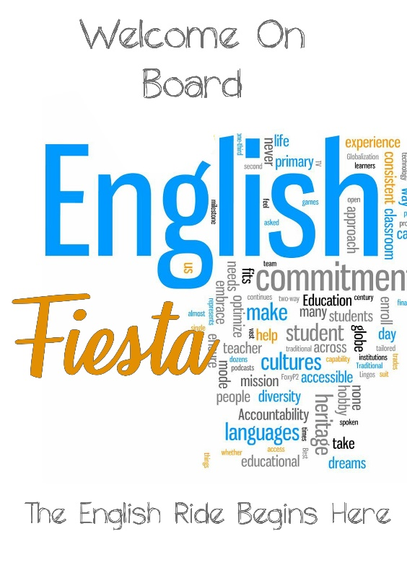

Show And Tell
Sana, KG wing organised Show And Tell Activity in the month of August to strengthen the verbal skills and to foster public speaking competency of the young minds.
It enabled them to improve their descriptive skills by communicating feelings, thoughts and emotions with words.
The inspiring presentation left no stone unturned to achieve a realistic appraisal of their skills and to discover the power of spoken words.
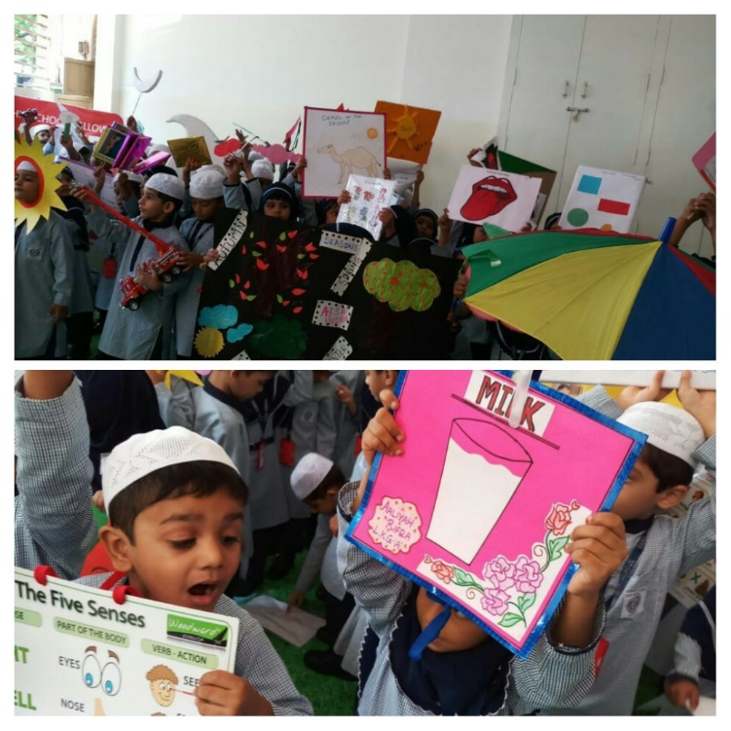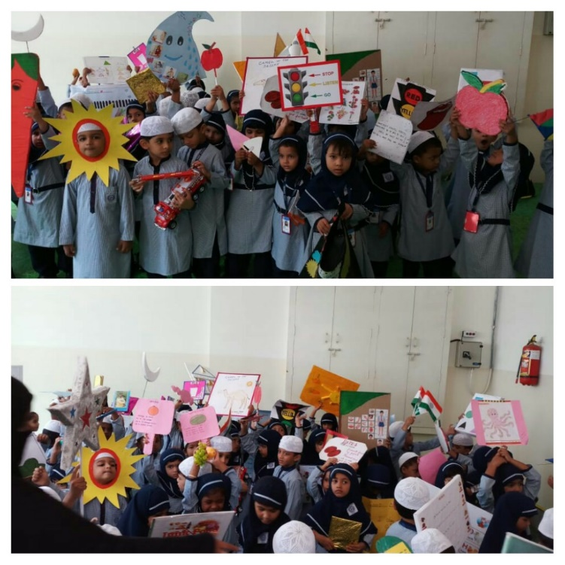

Just a Minute.
Sana School organised JAM for the primary students wherein they were given certain topics and had to speak on it for a minute. The children presented themselves confidently and shared their views on different topics like The best gift you have ever received, Importance of reading books, What I want to be when I grow up and many more.

