Circular No. CIR21-22/004 Date : 17.05.2021
Dear Parents
Assalaamu alaikum Wa Rahmathullahi Wa Barakaathuhu

HOLIDAY ASSIGNMENT
GRADE 1- ENGLISH
Reading comprehension – short stories
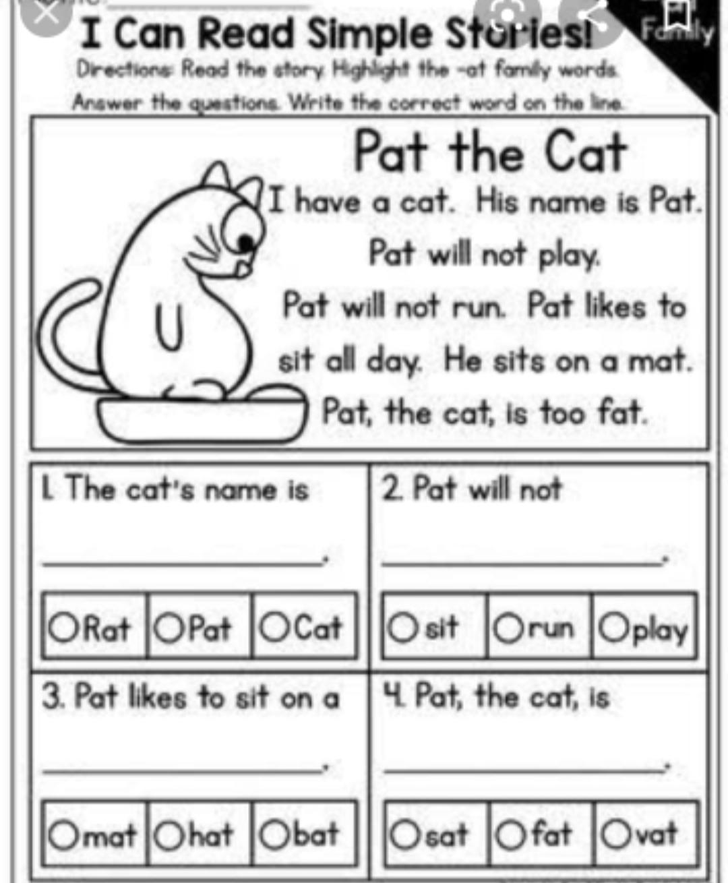

Reading comprehension
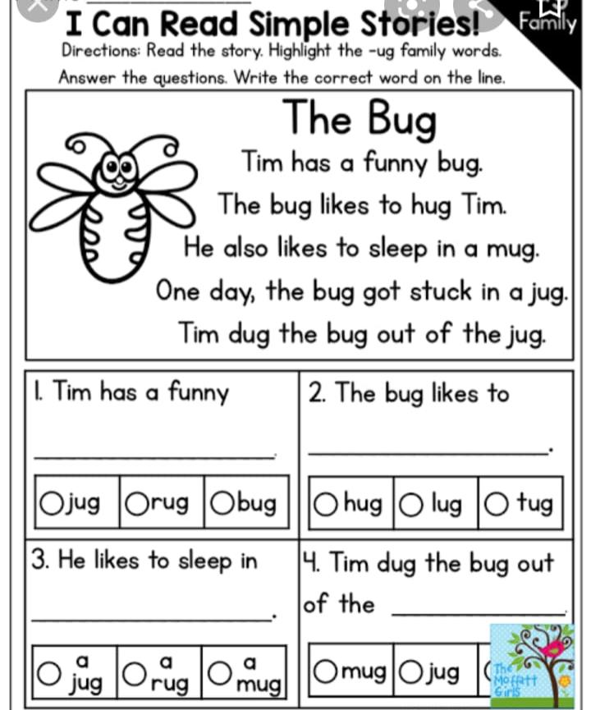

Sight words reading
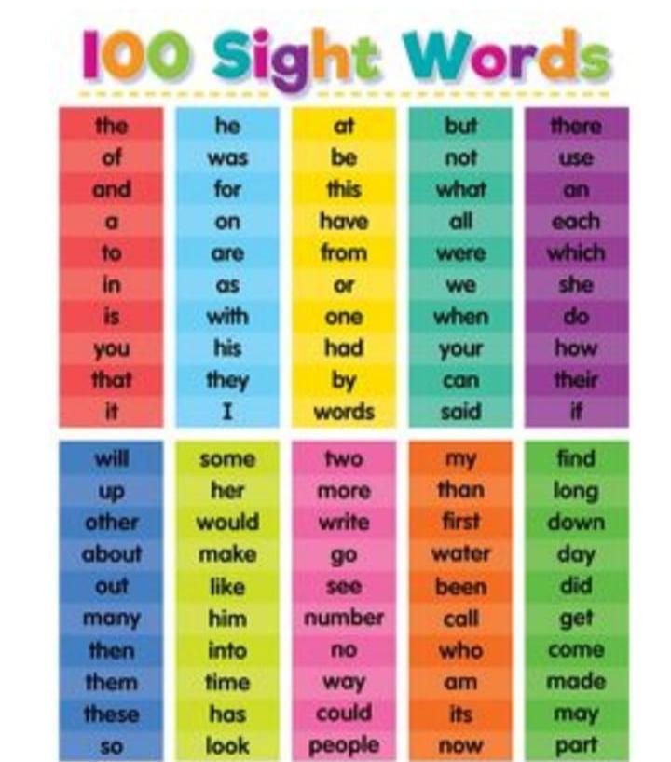

Handwriting practice 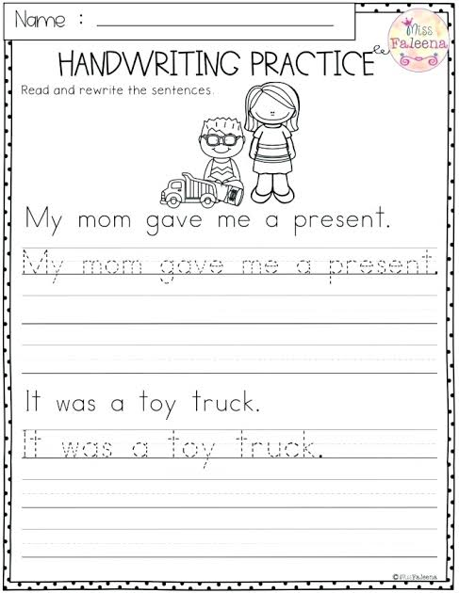

Handwriting practice
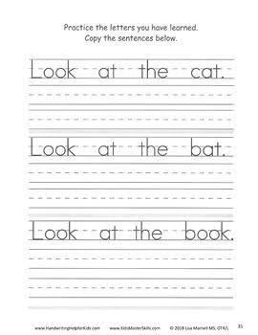

HOLIDAY ASSIGNMENT
GRADE 1
MATH

DEENIYATH
Revise the below mentioned surahs
- Surah Fathiha
- Kaafiroon
- Nasr
- Lahab
- Ikhlas
- Falaq and
- Naas

Management
Sana Model School

