Circular No. CIR21-22/004 Date : 17.05.2021
Dear Parents
Assalaamu alaikum Wa Rahmathullahi Wa Barakaathuhu

HOLIDAY ASSIGNMENT
GRADE 2- ENGLISH

ACTIVITY 1:
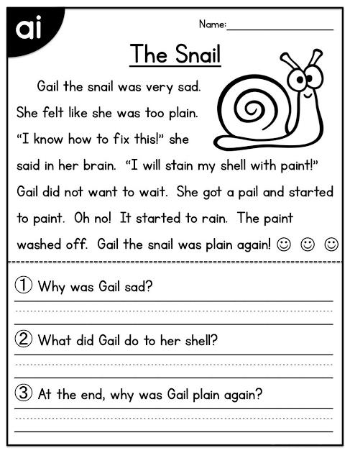
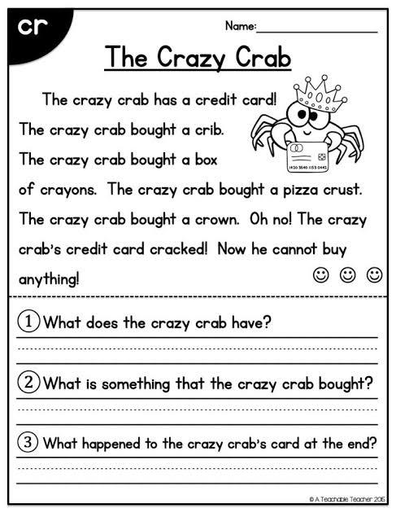
- Read these interesting stories & answer the questions (in your rough note book):-

ACTIVITY 2:

- Write lowercase letters in cursive in your 4 lined note book (2 alphabets per day):

ACTIVITY 3:
- Make one poster consisting of vowels, consonants,10 common nouns/proper nouns, 10 Singular/plural nouns. (in A4 size sheet paper or CW/rough note)
(or)

- Write a 4 to 6 lines poem about " Our Earth" on your own. (In A4 size sheet paper or CW/rough note)

HOLIDAY ASSIGNMENT
GRADE 2- MATH

ACTIVITY 1:
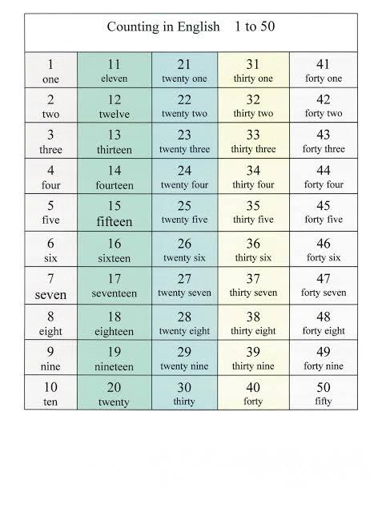
- Write number names up to 50 in your grade 2 Math c/w note book.

ACTIVITY 2:
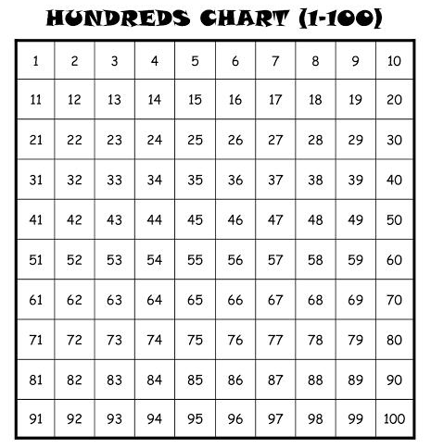
- Write numbers up to 100 in your grade 2 Math c/w note book.

ACTIVITY 3:
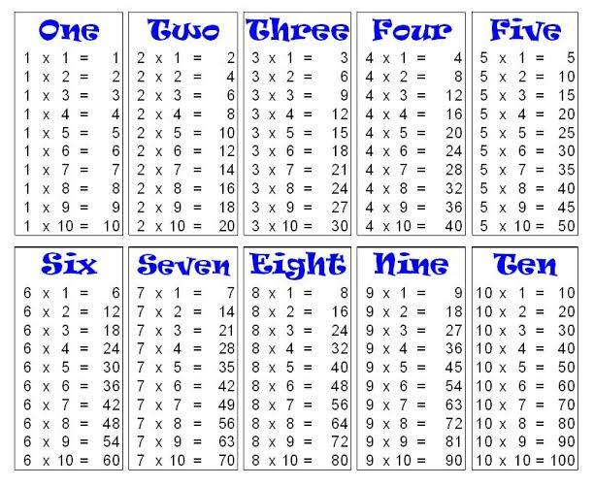
- Write Multiplication Tables: 1 to 10 (in the backside of your grade 2 Math c/w book)

HOLIDAY ASSIGNMENT
GRADE 2- DEENIYATH
Activity: Revise the below mentioned surahs
- Feel
- Quraish
- Humaza
- Takasur
- maoon
Management
Sana Model School

