Circular No. CIR21-22/004 Date : 17.05.2021
Dear Parents
Assalaamu alaikum Wa Rahmathullahi Wa Barakaathuhu
HOLIDAY ASSIGNMENT
GRADE 4- ENGLISH

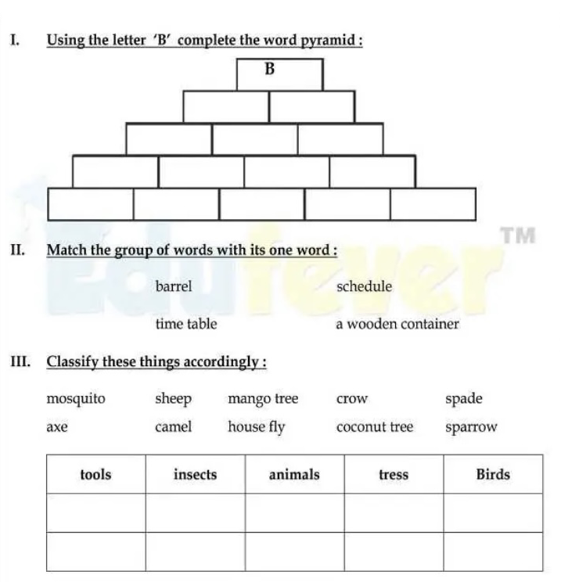
Let us ENJOY & ENGAGE!!!
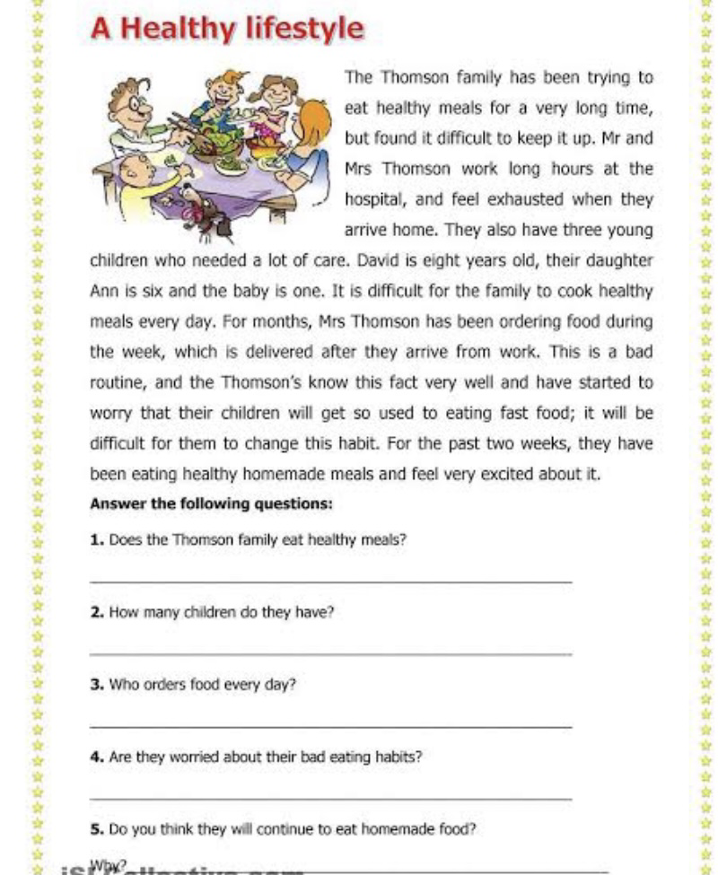
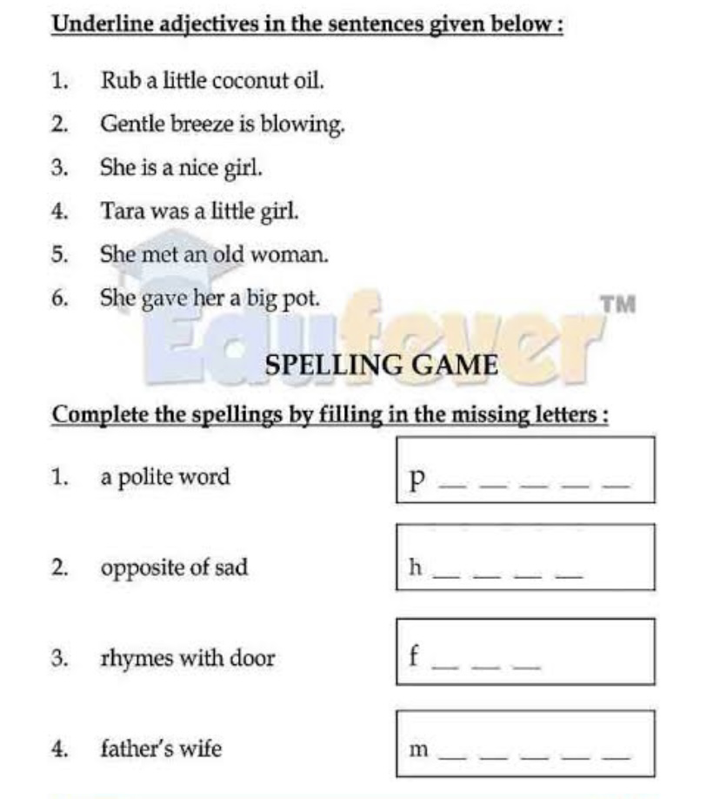
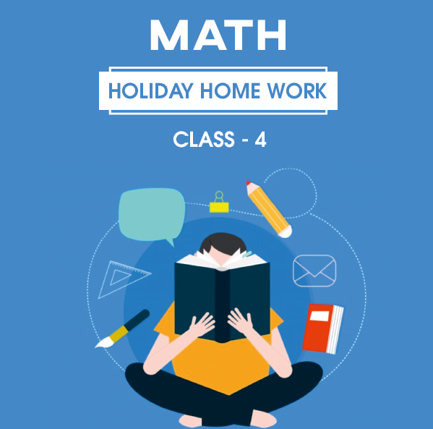

Part 1: Understanding basic concept
Complete the pattern
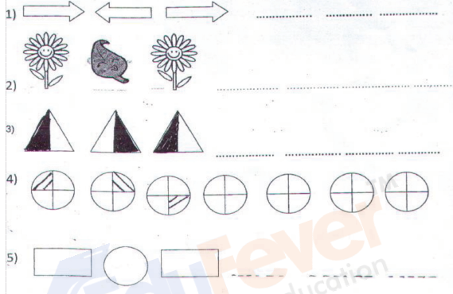
Part 2: Ability to compute
- Add the following
- 8853 + 1467 b) 214 + 286

- Subtract
- 2000 – 450 b) 2480 – 1241

- Find the product of
- 52 x 9 b) 37 x 7

- Divide
- 2450 ÷ 4 b) 7150 ÷ 6

Part 3: Problem solving ability
1. Meera plants 50 saplings in 10 rows. How many saplings are there in each row?
2. A toy factory manufactured 52,253 toys in January, 50,375 toys in February and 608,368 toys in March. How many toys were manufactured in the above-mentioned months in total?
3. A factory produces 5,376 bulbs per month. What will be its yearly production of bulbs?

DEENIYATH
- Revise Surah fajar to surah qadar

Management
Sana Model School

