Circular No. CIR21-22/004 Date : 17.05.2021
Dear Parents
Assalaamu alaikum Wa Rahmathullahi Wa Barakaathuhu

HOLIDAY ASSIGNMENT
GRADE 5- ENGLISH
I. Make sentences using the following words.
1. mess -
2. chased -
3. goldsmith -
4. opportunity -
5. desire -
6. fancy -
7. generously -
8. anxious -
9. cartoon -
10. sanitize -
II. Open your dictionary to find new words from
A-Z. ( Make sure you note down and know the meaning Of at-least one word from one alphabet ).
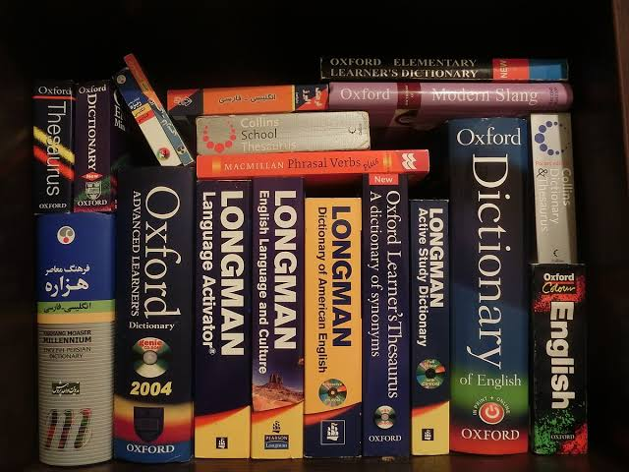

III. Read these short stories and find the meaning of the highlighted words.
- Having a Best Friend
A story tells that two friends were walking through the desert. During some point of the journey, they had an argument, and one friend slapped the other one in the face.
The one who got slapped was hurt, but without saying anything, wrote in the sand
“Today my best friend slapped me in the face.”
They kept on walking until they found an oasis, where they decided to take a bath. The one who had been slapped got stuck in the mire and started drowning, but the friend saved him. After he recovered from the near drowning, he wrote on a stone;
“Today my best friend saved my life.”
The friend who had slapped and saved his best friend asked him;
“After I hurt you, you wrote in the sand and now, you write on a stone, why?”
The other friend replied;
“When someone hurts us we should write it down in sand where winds of forgiveness can erase it away. But, when someone does something good for us, we must engrave it in stone where no wind can ever erase it.”

Moral of the story:
Don’t value the things you have in your life. But value who you have in your life.

2. The Greedy Lion.
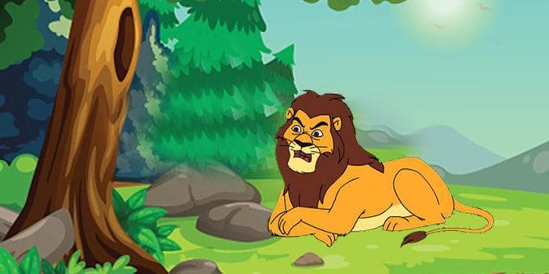
Short Moral Stories - The Greedy Lion
It was an incredibly hot day, and a lion was feeling very hungry.
He came out of his den and searched here and there. He could find only a small hare. He caught the hare with some hesitation. “This hare can’t fill my stomach” thought the lion.
As the lion was about to kill the hare, a deer ran that way. The lion became greedy. He thought;
“Instead of eating this small hare, let me eat the big deer.”
He let the hare go and went behind the deer. But the deer had vanished into the forest. The lion now felt sorry for letting the hare off.
Moral of the story:
A bird in hand is worth two in the bush.

3. The Struggles of Our Life
Short Moral Stories - The Struggles of our Life
Once upon a time a daughter complained to her father that her life was miserable and that she didn’t know how she was going to make it.
She was tired of fighting and struggling all the time. It seemed just as one problem was solved, another one soon followed.
Her father, a chef, took her to the kitchen. He filled three pots with water and placed each on a high fire.
Once the three pots began to boil, he placed potatoes in one pot, eggs in the second pot and ground coffee beans in the third pot. He then let them sit and boil, without saying a word to his daughter.
The daughter, moaned and impatiently waited, wondering what he was doing. After twenty minutes he turned off the burners.
He took the potatoes out of the pot and placed them in a bowl. He pulled the eggs out and placed them in a bowl. He then ladled the coffee out and placed it in a cup.
Turning to her, he asked. “Daughter, what do you see?”
“Potatoes, eggs and coffee,” she hastily replied.
“Look closer” he said, “and touch the potatoes.” She did and noted that they were soft.
He then asked her to take an egg and break it. After pulling off the shell, she observed the hard-boiled egg.
Finally, he asked her to sip the coffee. Its rich aroma brought a smile to her face.
“Father, what does this mean?” she asked.

He then explained that the potatoes, the eggs and coffee beans had each faced the same adversity-the boiling water. However, each one reacted differently. The potato went in strong, hard and unrelenting, but in boiling water, it became soft and weak.
The egg was fragile, with the thin outer shell protecting its liquid interior until it was put in the boiling water. Then the inside of the egg became hard.
However, the ground coffee beans were unique. After they were exposed to the boiling water, they changed the water and created something new.
“Which one are you?” he asked his daughter.
“When adversity knocks on your door, how do you respond? Are you a potato, an egg, or a coffee bean?”
Moral of the story:
In life, things happen around us, things happen to us, but the only thing that truly matters is how you choose to react to it and what you make out of it. Life is all about leaning, adopting and converting all the struggles that we experience into something positive

4. The Lion & The Poor Slave.

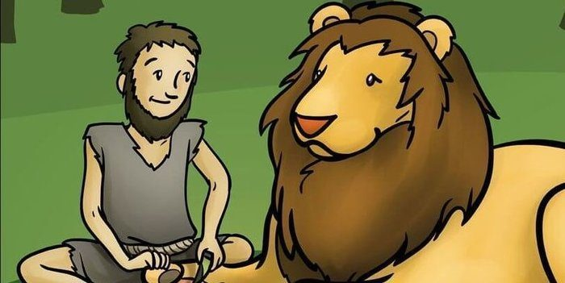
A slave, ill-treated by his master, runs away to the forest. There he comes across a lion in pain because of a thorn in his paw. The slave bravely goes forward and removes the thorn gently.
The lion without hurting him goes away.

Some days later, the slave’s master comes hunting to the forest and catches many animals and cages them. The slave is spotted by the masters’ men who catch him and bring him to the cruel master.
The master asks for the slave to be thrown into the lion’s cage.
The slave is awaiting his death in the cage when he realizes that it is the same lion that he had helped. The slave rescued the lion and all other caged animals.
Moral of the story:
One should help others in need, we get the rewards of our helpful acts in return.

HOLIDAY ASSIGNMENT
GRADE 5
MATH

ACTIVITY: 1 MATHS ALBUM
- Collect some pictures with 'Price Tag' from the magazines (Eg. Laptop, Toys, Mobile, Car etc..) and Paste it in your album. Now your album will be colourful. Your maths task is - Write all the prices of the pasted items and make their total, now you will get a large number, write the number names.
ACTIVITY: 2 BILLS
- Collect some 'Bills' that you have recently purchased and paste it in your album, go through the table heads of the bill.
ACTIVITY: 3 TIME
- Write your daily routine (day today activities) along with the time. Now write the time in 12 hour and 24-hour format
ACTIVITY: 4 MEASUREMENT
- Measure the items listed below with a tape or scale and write in the units of centimetre and meter.
-->Table
-->Door
-->Window
-->Mobile
-->Laptop
-->Fridge
-->Cot
-->Book
-->Your Height

DEENIYATH:
Revise the below mentioned surahs

- Surah fajar,
- Gaashiya,
- Aala,
- Thariq,
- Burooj,
- Inshiqaaq
Management
Sana Model School

