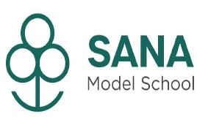

MI CHAMP- 2021
ONLINE LIVE READING CONTEST
Reading is power, Reading is rewarding, Reading builds vocabulary, Reading expands knowledge.
TODAY A READER, TOMORROW A LEADER.
Reading is the gateway for children that makes all other learning possible”.

MIKIDS – SIP Academy India Pvt . Ltd. organized a live reading contest only for the students of Grade II providing an opportunity to showcase their reading skills.
PRELIMINARY
Nearly 12 students from our school participated in the contest.
A Preliminary Round was Conducted on 10th November -2021 where a short story was shared with all the participants ( Story - Fortune and the Poor man) Students read the same and shared their recordings which was then submitted to MIKIDS.
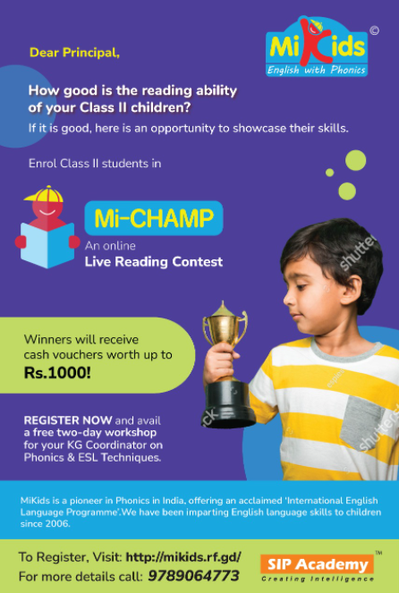
Participants as follows:
- Mehvish Moheed
- Sulaimaan. K
- Farzana Sharif
- Muhammad Qasim
- Muhammad Yusuf
- Aaqib Aliyar
- Mohammed Rayyan
- Muskaan Fathima
- Asfar Hamid. S
- Iffat Hidhaya
- Mehreen Fathima
- Akhila Fathima

FINALS
The best reader was shortlisted among the participants from various schools and the finals was conducted LIVE on 25 November 2021 on the Zoom platform.
The contest was to Read 200 words in 2 minutes.
Our student Ms. Mehvish Moheed read nearly 165/200 words in 2 minutes. Alhamdulillah
She read the story with clear articulation, perfect voice modulation and achieved the
MI CHAMP WINNER Title and will receive cash voucher worth Rs.1000 for the year 2021.

OUR HEARTY CONGRATULATION! TO THE WINNER
Ms. MEHVISH MOHEED
